Report Summary
Project Title: Diabetic Retinopathy Detection Using Deep Learning
We worked on this project in three main phases. Each phase had a different approach to solve the problem and improve the results.

Phase 1: Reproducing the Research Paper
First, we followed the method used in the research paper. We used a simple Convolutional Neural Network (CNN) built from scratch. The dataset was small and balanced, with 200 images for each class.
Steps followed:
- Resize all images
- Normalize pixel values
- Use one-hot encoded labels
- Train a CNN with three convolution layers followed by dense layers
Results:
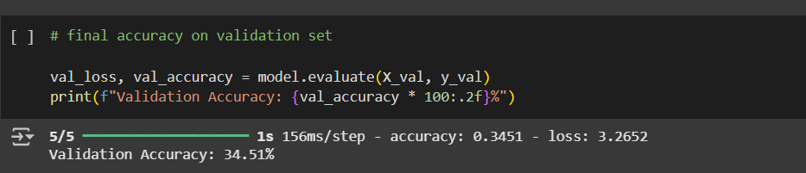
- Validation accuracy was around 34 percent
- The model mostly predicted class 0
- The results were poor for the other classes
- The model could not learn enough from the small dataset

Phase 2: Trying to Improve with Transfer Learning
Next, we tried to improve results by using a better model. We used MobileNetV2, a model that was already trained on a large dataset. We only changed the last layer to match our task.
Changes made:
- Used MobileNetV2 with pretrained weights
- Replaced only the final layer for 5-class prediction
- Used callbacks like ReduceLROnPlateau and EarlyStopping
- Added class weights to deal with imbalance
Results:
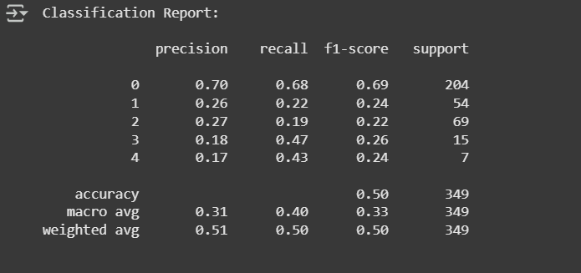
- Validation accuracy increased to around 50 percent
- It performed better on class 2
- It still performed badly on classes 3 and 4
- The model was better than the first one, but still had limitations

Phase 3: Combining Both Approaches
In the last step, we used a mix of both ideas. We used MobileNetV2 as the base model but removed its top layers. We then added our own custom classifier layers on top.
What we did:
- Used MobileNetV2 without the top layer
- Added custom dense layers with dropout and batch normalization
- Used focal loss instead of normal loss to better handle class imbalance
- Used the full dataset with all gradable images
Results:
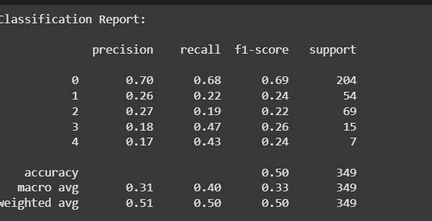
- Validation accuracy was around 50 percent
- The model showed better balance across all classes
- Class 3 and class 4 predictions improved slightly
- The model was more stable and had fewer overfitting issues

Final Comparison

Method | Accuracy | Good Points | Weak Points
Paper Approach | 34.5% | Easy to build, followed the paper | Poor accuracy, missed rare classes
Transfer Learning | 50% | Better learning, used pretrained model | Weak on rare classes
Hybrid Model | 50% | Balanced results, improved generalization | Limited by small class sizes

Final Thoughts
We started by copying the research paper. Then we tried to improve it using a pretrained model. In the final step, we combined both ideas. We tried to solve the problem of imbalance using techniques like focal loss and resampling. The final model was more balanced and more reliable, even though we could not reach very high accuracy due to limited data.

